CARFINDER APPLICATION

PROBLEM DEFINITION

Some people can be curious about the cars.But he or she can not achieve the any information about the car.In this application we can prevent this.A user who would to know about something car (model,engine,torque,horsepower etc.) can achieve that.

SYSTEM REQUIREMENTS

I needed somethings while I was creating this application.

-Using Kotlin programming language

-Using Android Studio Interface

-Using Google (for handling some informations about the car)

-Using Youtube (for learning Kotlin)

As I indicated to below,we have two page in our application;

One of them is admin page: Anohter one is users page:

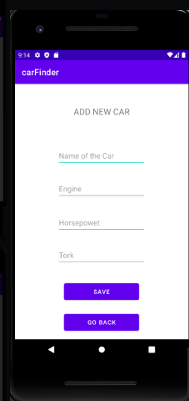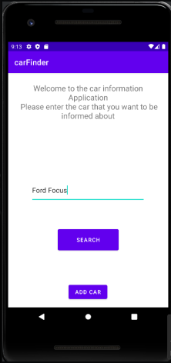

In admin page,the admin can add some cars and its properties.Admin has ability of the managing the system.



Then our car enthusiast wants to search a car and he or she wants to handle some informations about that car.



(As I indicated to top,this is users page)

Finally the car enthusiast can handle the what he or she want.

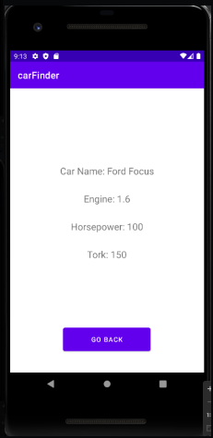

As we see we can handle the engine,horsepower and torque of Ford FOCUS.